LONGFORD COUNTY COUNCIL
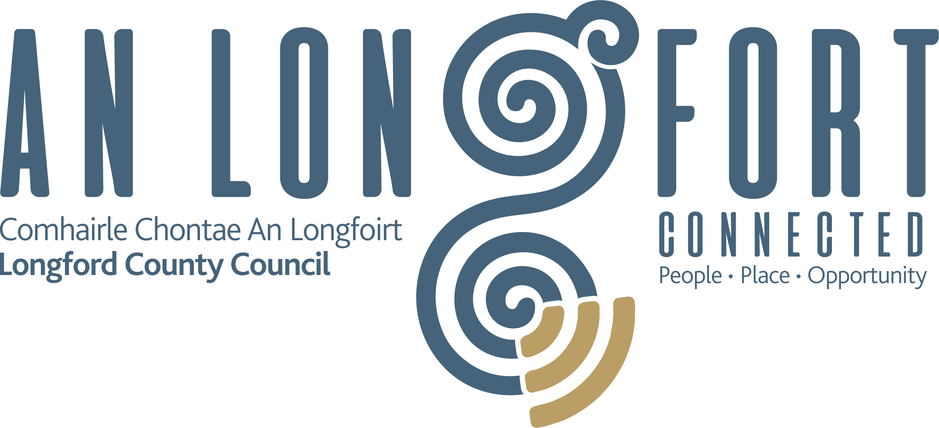

REQUEST FOR QUOTATION

Subject of Quotation
Design & produce a marketing Brochure for Longford County Council (LCC) that will assist LCC and different authorities in their efforts to promote County Longford as a viable investment location. The brochure will be available in printed format, but digital content will form part of the final product.
Key Dates
Issue Date | Monday 16th October 2023
Closing Date for Queries | Friday 27th October 2023
Closing Date for Quotation | Friday 3rd November 2023
Contact for Queries
madegboyega@longfordcoco.ie

CONTENTS
1 ABOUT THE CONTRACTING AUTHORITY 3
1.1 The Contracting Authority 3
2. OBJECTIVES 3
2.1 Brochure Objectives 3
3. SCOPE OF REQUIREMENT 3
3.1 Background 3
3.2 Specification of requirements 4
3.3 Design and content guidelines 5
3.4 Target market 5
3.5 Content 6
3.6 Anticipated outputs 6
4. PAYMENT ARRANGEMENTS 7
4.1 Currency and payment 7
5. EVALUATION CRITERIA 7
5.1 Suitability 7
5.2 Award Criteria 8
5.3 Copyright 8
6. INSTRUCTIONS FOR QUOTATION 9
6.1 Closing Date and Submission of Quotation 9
6.2 Queries 9
6.3 Confidentiality 9
6.4 Conflict of interest/ Data Protection 9

ABOUT THE CONTRACTING AUTHORITY

1.1 The Contracting Authority
Longford County Council, herein after referred to as the Contracting Authority, is the authority responsible for this procurement.
Further information is available on our corporate website https://www.longfordcoco.ie/

OBJECTIVES

2.1 Brochure Objectives:
Showcase County Longford as an attractive investment destination.
Highlight key industries, sectors, and opportunities in Longford.
Promote the county's strategic location, infrastructure, and connectivity.
Emphasize the support and incentives available to investors.

SCOPE OF REQUIREMENT

3.1 Background
Longford County Council is seeking the services of a marketing agency to design and produce a brochure that will assist in promoting County Longford as a viable investment location. The purpose of this brochure is to attract potential investors and highlight the economic advantages, opportunities, and quality of life that Longford has to offer.
Longford County is a dynamic, progressive area, centrally located in the heart of Ireland. This vibrant location has much to offer residents, visitors, students, and businesses.
The remit of Longfordcoco.ie is broad, with the website and supporting marketing activity working to promote and position the county as a county of choice, showcasing the value proposition of the county: centrality, access to talent, the existing enterprise base, enterprise supports, training and education, regional recreational assets, arts, and cultural assets.
- Invest
  - Promoting the county as a destination of choice for investment, highlighting regional industry clusters, infrastructure, opportunities and supports.
- Live
  - Promoting the county as a place to live, whether relocating for more space, better quality of life or affordability. Also highlighting the facilities and amenities of the county in culture, arts, heritage.
- Work
  - Attracting quality talent to work in the county. Promoting opportunities for those who may relocate or who may currently commute out of the county each day, including the remote/blended opportunities provided by our network of remote working hubs.
- Study
  - Promote opportunities across the region from work readiness and literacy courses, through to university and post graduate levels. The midlands region gained our first university with TUS and this presents many opportunities for the region in collaboration with our ETB’s and primary and second level schools.
- Business
  - Highlighting the opportunities of doing business in the county, in particular the enterprise eco-system which exists through local enterprise offices and other government agencies. This element is intended for those at all stages of their business journey and highlights the opportunities that exist in the county.
- Visit
  - Promote the wealth of amenities and attractions in Longford County. Key attractions include the St Mels Cathedral in Longford town, Center Parcs, Corlea bog, Knights & Conquests, Newcastle woods, numerous Greenways and Blueways, and much more. In this context, it’s highlighting the wide-open spaces, eco-tourism, and quieter pace to attract those who live in the region, or move to the region, to experience and be proud of their locality.

3.2 Specification of Requirements
Brochure will highlight Longford's strengths as an investment location. Key points to emphasise include but not limited to:
- Central location in Ireland
- Important Axis Point (North/South, East West)
- Nature & strength of existing enterprise base
- Enterprise cost base compared to average
- Staff retention rates compared to average
- Quality of education, leisure, and sporting facilities
- Housing costs compared to average
- Regional importance of TUS university
- Vibrant new communities/ strength of integration
- Local Authority Support/ Open door policy
- Enterprise Development Agencies - IDA, EI, and LEO
- Proximity to Dublin and strategic transport links.
- A diverse range of industries and sectors.
- Business-friendly policies and incentives.
- Modern infrastructure and connectivity.
- A thriving community and a high quality of life.
3.3 Design and content guidelines:
The finished brochure should be a comprehensive promotional brochure that can be directed at different shareholder groups but particularly those groups that are seeking investment locations or opportunities. While this document has defined different parameters that we would like to see covered, we are open to discuss and agree an approach around design and content that might be put forward by the successful tenderer.
The brochure should:
Convey the high quality of life in Longford
Have a professional, modern, and clean design.
Incorporate the Longford County Council logo and color scheme.
Have high-quality images that showcase Longford's natural beauty and economic assets.
Have clear and concise language, with a focus on key selling points.
Include testimonials or success stories from existing businesses.
Be formed out of an assessment of existing comparable brochures.

3.4 Target market:

It will be essential to ensure that the target market is properly defined and segmented to allow for appropriate messaging to be developed. Priority should be given to the A1 segment.
  - A1 segments to include:
    - Domestic and international investors
    - Potential industrial Investors/Developers
    - Business leaders and decision-makers
    - Government authorities and economic development agencies
    - Expanding enterprises seeking second site locations
    - Potential Hotel developers
    - Potential stakeholders and partners
  - A2 Segments to include:
    - New employees moving into area
    - The Longford Diaspora
    - People who want to move to live in Longford
    - Tourists
- 3.5 Content:
The product will contain data that is relevant and pertinent to the different market segments. It will be statistically based where possible drawing on all data sources available to include CSO 2022 data.
- The successful company will be responsible for securing and delivering the photography and videography
- Professional images that support written content will be used.
- Visual presentation should include short video soundbites (min 10) that can be utilised in presentations. Each soundbite should be 20 to 30 seconds long and each highlighting a different asset
- Testimonials from key stakeholders can form part of the brochure and the video soundbites
- Maps - Several maps will be integrated into the text that will assist with the presentation of key data.
  - Demographic map of County Longford,
  - Map highlighting Longford's strategic location in Ireland
  - Location of main industries,
  - Zoned lands
3.6 Anticipated Outputs:
- Digital brochure compatible with Longford County Council and Local Enterprise Office Longford websites
- Printed format (preferably in book format but open to alternatives)
The brochure should be produced in a manner that enables updates or revisions to be made in an economical fashion if needed.
The source files and design work will be provided upon completion.

4 PAYMENT ARRANGEMENTS

4.1 Currency and payment
The currency in which all prices and rates shall be tendered, and which payments under the contract will be paid, shall be Euro (€). All prices and rates quoted should be exclusive of VAT, with the applicable rate of VAT clearly indicated.
Payment will be made on receipt of invoices in accordance with the terms agreed with the Contracting Authority.

5. EVALUATION CRITERIA

5.1 Suitability
The Contracting Authority will only consider tenders from competent and financially sound and compliant economic operators. Please include the following information in your response:
- General economic operator information.
- Confirmation of tax compliance.
- Copy of current insurance certificate. The minimum cover for this project is employer’s liability (€13m), public liability (€6.5m), product liability (€6.5m), and professional indemnity (minimum of €50,000). Indemnity to Longford County Council will need to be included on the policy before work commences.
- Confirmation via declaration that the economic operator is not bankrupt, guilty of corruption, fraud, money laundering, membership of a criminal organisation, not involved in child labour and/or human trafficking and is fully compliant with all its statutory obligations.

5.2 Award Criteria
The contract will be awarded based on a quality and cost evaluation as assessed by the Contracting Authority, who is not obliged to accept the lowest or indeed any quotation. The following criteria will be applied:
Criterion | Marks
- Approach to completion of project | 30 Marks
- Relevant expertise and examples of previous work undertaken | 40 Marks
- Value for Money | 30 Marks
- Total maximum score available | 100 Marks

Bidders may be short-listed and required to meet with the Local Authority to discuss their approach, experience, and other capabilities with an assessment panel. Should this be the case the Agency will use the criteria as stated above to revisit the original scores following clarifications and presentations.

5.3 Copyright
The Contracting Authority will have copyright ownership of any material developed for use by the Contracting Authority under the terms of this quotation. The successful tenderer may have a non-exclusive licence to use such material but only for its own purposes (subject to agreement).

INSTRUCTIONS FOR QUOTATION

6.1 Closing Date and Submission of Quotation
The closing date for receipt of quotation is listed on the title page of this document. quotations that are received late will not be considered in this competition.
Quotation should be submitted to the email address listed on the title page of this document.

6.2 Queries
All queries in connection with this quotation should be made through email to madegboyega@longfordcoco.ie

To ensure a fair and transparent procurement process no approach of any kind in connection with this quotation should be made to any other person within, or associated with, Longford County Council. Failure to comply may result in disqualification from the process.

6.3 Confidentiality
The distribution of the quotation documents is for the sole purpose of obtaining offers. The distribution does not grant permission or licence to use the documents for any other purpose. Economic operators are required to treat the details of all documents supplied in connection with the quotation process as private and confidential.

6.4 Conflict of Interest / Data Protection
Any conflict of interest involving a tenderer (or tenderers in the event of a consortium bid) must be fully disclosed to the Contracting Authority. Any registrable interest involving the tenderer and the Contracting Authority or employees of the Contracting Authority, or their relatives must be fully disclosed in the tender submission or should be communicated to the Contracting Authority immediately upon such information becoming known to the tenderer, in the event of this information only coming to their notice after the submission of a bid and prior to the award of the contract. Failure to disclose a conflict of interest may disqualify a tenderer or invalidate an award of contract, depending on when the conflict of interest comes to light.
Data Protection Laws” means all applicable national and EU data protection laws, regulations and guidelines including but not limited to Regulation (EU) 2016/679 on the protection of natural persons with regard to the processing of personal data and on the free movement of such data, and repealing Directive 95/46/EC (the “General Data Protection Regulation”), the Data Protection Act, 2018 and any guidelines and codes of practice issued by the Data Protection Commission or other supervisory authority for data protection in Ireland from time to time.
The Contracting Authority will be a Controller (where Controller has the meaning given under the Data Protection Laws) in respect of any Personal Data (where Personal Data has the meaning given under the Data Protection Laws) required to be provided by the Tenderer in response to this Request for Quotation.
The Tenderer, as Controller in respect of any Personal Data provided by it in its Tender, is required to confirm by way of statement in the “Declarations” section of the accompanying Quotation Response Document (QRD) that all Data Subjects (where Data Subject has the meaning given under the Data Protection Laws) whose Personal Data is provided by the Tenderer have consented to the processing of such Personal Data by the Tenderer, the Contracting Authority, the Evaluation Team and the supplier of the etenders.gov.ie website, for the purposes of the participation of the Tenderer in this Competition or that the Tenderer otherwise has a legal basis for providing such Personal Data to the Contracting Authority for the purposes of its participation in this Competition.

